**Q: 8**

**Calculator**

**Time to solve the problem**

**30 minutes**

**Level 1**

**Topics**

**Grid**

**Problem Statement**

**Build the given layout using Grid and its properties, on hovering on each button, button should change the color. 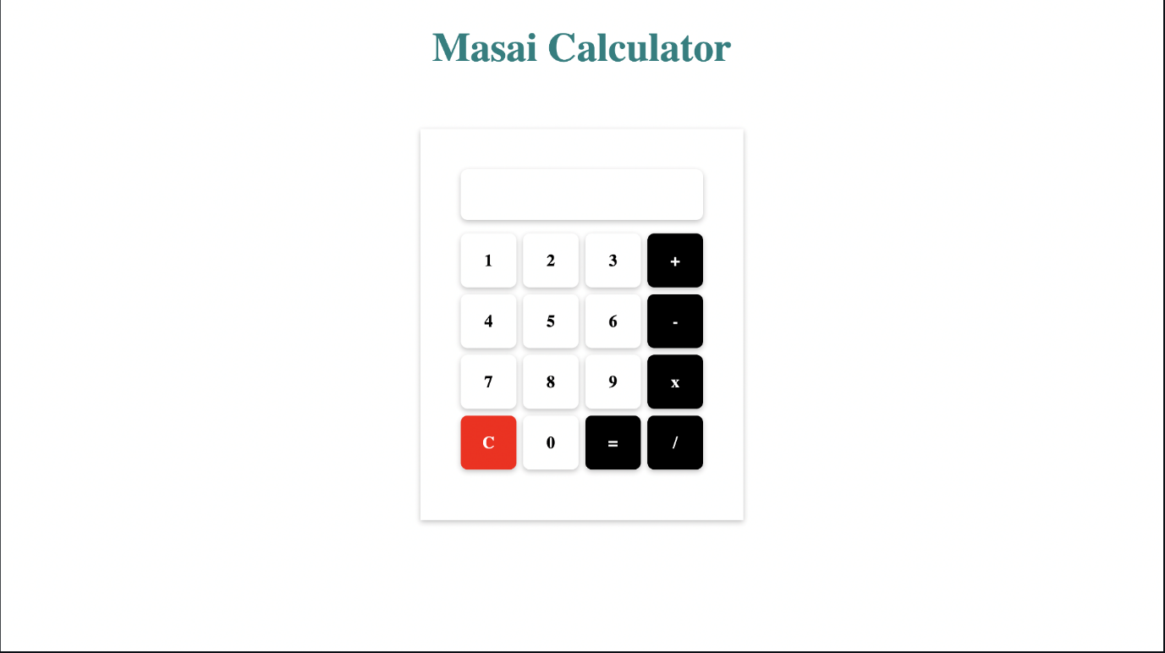**

**Submission Guidelines**

**Submit GitHub link**